Handwritten and Printed Bengali Script Word Segmentation Using Structural Analysis

Pritilata Biswas^{1*}, Sumaia Afrin Prity², Parvez Abedin Siddique³, Arifa Islam Champa⁴
- Student, Dept of Computer Science And Engineering
Bangladesh Army International University Of Science And Technology, Cumilla, Bangladesh
Email: pritilata.biswas66@gmail.com tel : +8801923388240
- Student, Dept of Computer Science And Engineering
Bangladesh Army International University Of Science And Technology, Cumilla, Bangladesh
- Student, Dept of Computer Science And Engineering
Bangladesh Army International University Of Science And Technology, Cumilla, Bangladesh
- Lecturer, Dept of Computer Science And Engineering
Bangladesh Army International University Of Science And Technology, Cumilla, Bangladesh

Abstract

Bangla character recognition is becoming a momentous issue in several years but it becomes a challenge to get good performance due to the segmentation and many of them are similar. It remains largely unsolved due to the presence of many ambiguous handwritten characters and excessively swigs Bangla handwriting. Even many flourished existing methods do not lead to satisfactory performance in practice that related to Bangla character recognition. In this paper, we mainly focused on the segmentation process which is the backbone of the recognition phase. At the preprocessing part, the input image is processed by using various filters like grayscale filter, bilateral filter, skew angle correction and binarization. Then for segmentation purposes, the lines of Bengali script are segmented by horizontal projection profile (HPP) and then words for each line are segmented by vertical projection profile (VPP). Here HPP and VPP are part of structural analysis. This Structural analysis is the process of breaking words down into their basic parts to determine word meaning. In our system, we mainly tried to identify the words properly that solve the problem of word segmentation for Bengali script and thereby increases the accuracy of the segmentation process.
Keywords- Bengali character, Image binarization, Segmentation, Horizontal Projection Profile (HPP), Vertical Projection Profile (VPP).
- Introduction:
Bangla is an eastern Indo-Aryan language with around 300 million speakers mainly in Bangladesh, and in the Indian states of West Bengal, Tripura and South Assam. The Bengali alphabet is derived from the alphabet of Brahmi . It is also related to the Devanagari alphabet, from which it started to diverge in the 11th Century AD. The current form of printed Bengali alphabet first appeared in 1778 when Charles Wilkins developed printing in Bengali. A few archaic letters were modernized during the 19th century. Bengali script followed a different line of development from that of Devanagari and Oriya scripts, but the characters of Bengali script generally coincided. By the 12th century CE, the Bengali alphabet was nearly fulfilled, although natural changes continued to take place until the 16th century. Some sensible alterations were also made in the 19th century. Bangla is written from left to right. There are no other capital letters. The script is characterized by many conjuncts, downstrokes and other features that hang from a horizontal line. The punctuation marks, save one, are all taken from the 19th-century English. Though Bangla is a very flourishing and old language, the matter of regret is its computerization has not yet gone much far. In fact, dedicated research and improvement for Bangla computerization have just been started from the last decade. In any language, there are two forms of a written document. One is a hand-written document and the other is printed document. Most of the characters of Bangla hand-written words are touching which is the prime bottleneck of this kind of documents. Besides, the shape of Bangla hand-written characters are extremely diversified. Doing proper segmentation of these scripts is really tough. Hence, creating an efficient and useful OCR system for Bangla hand-written scripts is really a great challenge for computer scientists. On the other hand, the printed Bangla documents are much simpler than that of the previous one; because, in printed scripts variations in style of Bangla characters are limited. In the case of printed documents, there are two basic classifications that are computer composed documents and type-machine composed documents. The primary alphabet of Bangla script is quite large compared to the alphabet sets of English and other western languages. It comprises of 11 vowels, 39 consonants and 10 numerals. The total number of symbols is approximately 300. Besides this huge quantity of symbols, there are various types of writing style of those. All these aspects have thrown a great challenge to the researchers in developing a comprehensive OCR for Bangla handwritten scripts. Segmentation of Bangla handwritten text is the pre-process of handwritten text. The Bengali script is also used for representing other languages like Meithei and Bishnupriya Manipuri, and there is a time when it used to write Sanskrit within Bengal [1]. Most of the Bengali characters are topologically connected [2]. They can be easily classified using this connectedness property. This classifying or segmentation of the Bengali character is the most challenging task in making a Bengali Optical Character Recognition (OCR). In Bengali, there is a combination of basic, modified and compound characters. The combination of characters can be more than 300. Here, Bengali character segmentation is the most challenging task. So, we need some robust techniques that can classify these compound characters.
Table 1: Some compound characters in the Bengali script [2].
Compound Character | Formation of the Character
ক্ট | ক+ট
ন্ড | ন+ড
ষ্ট্র | ষ+ট+র
As we know Bengali script characters are connected with a Matra line, so the characters can be easily recognized by the connected component analysis [2]. In this paper, our main contribution is to improvise the method of analyzing the line segmentation and word segmentation of the Bengali script using Horizontal Projection Profile and Vertical Projection Profile respectively.
- Related works
Character recognition complexity varies among different languages due to distinct shapes, strokes and number of characters. The performance of a recognition system depends on a number of factors such a segmentation, feature extraction, and sometimes grouping or classification of individual characters. Correct segmentation is the most important step among these. Segmentation consists of three phases: Line Segmentation converts text page into lines, Word Segmentation converts a line into words and Character Segmentation converts a word into individual characters. The number of characters in Bangla is large (more than 300) and two or more characters combine to form new character shapes called compound character. Modifiers make it more difficult to segment at the character level. Some characters or parts of the characters lied on the upper part of the matra line, some are at the lower part, below the baseline. Most of them are overlapping characters. So it is a really challenging task to segment Bangla script in the character level [2].
The segmentation of the Bengali script is analyzed by various authors who proposed various methods. These are described below:

Zahan et al [2] proposed a complete and robust segmentation process for printed Bangla script. They have used connected component analysis based two-zone approach that can address all the problems associated with the character segmentation of Bangla script with less effort. In their system, they have tried to identify the matra line properly. Then using this information they have divided the script into two zones (upper and lower zone). Their proposed method solves the problems of character segmentation in Bangla script and thereby increases the accuracy of the segmentation phase that leads to a greater accuracy of overall optical character recognition (OCR) system.
Obaida et al [3] described a stroke-whitespace based algorithmic approach that harnesses horizontal projection techniques to correct the skewness of writings precisely for some languages. They proposed an easier and effective process named as OJ method that corrects the skewness of images for any degree of rotation. In essence, the paper deals with the images that are rotated by 180 ̊, using Stroke-Whitespace distance method.
Goswami et al [4] proposed a robust method for detecting the headline region. A predictive algorithm is developed for effectively identifying overlapping characters and then selecting the cut-borders for segmentation. This method can be successfully used in achieving high recognition results.
Chaudhuri & Pal [7] proposed the first complete Bangla OCR system for printed documents. Using horizontal and vertical projection profile analysis and headline removal technique they segmented the documents into lines, words, and characters. They also divided the words into three zones using headline and baseline detection techniques.
Mahmud et al [9] proposed a recognition process for isolated as well as continuous printed Bangla characters. This process also supports multi-font Bangla script recognition. Preprocessing involves segmentation at various levels. They used piecewise linear scanning, greedy search algorithm and baseline detection technique for character segmentation.
Mahmud et al [10] used the projection profile-based method for segmenting Bangla script. For character segmentation, they used the vertical scanning method. Depth First Search (DFS) algorithm also used for overlapped character segmentation.
Mehedi et al [11] proposed a new approach using characteristic functions and a hamming network for segmentation and recognition of printed Bangla text. They used a set of characteristic functions for segmenting the upper portion (above matra line) and characters that come under the Baseline (three-zone approach). It also uses a combination of Flood-fill and Boundary-fill algorithm for segmenting some characters that cannot be segmented using the traditional approach.

- Methodology
A typical OCR system consists of preprocessing, segmentation, recognition and post-processing parts. In this paper, we mainly focused on the segmentation process which is the backbone of the recognition phase. Figure 1 depicts the processes that were followed for word segmentation. At first, the input image will be converted into a grayscale image using a grayscale filter and using a bilateral filter. Then using bit plane slicing the input image will be binarized. For skew correction, we will use the skew angle technique [3]. There is a horizontal gap between the two lines. We will detect those gapes by horizontal projection profile (HPP). Vertical projection profile (VPP) will be used in word segmentation from extracted lines.
Step 2: line segmentation
- Apply HPP
Step 1: Input Processing
- Apply grayscale filter
- Apply bilateral filter
- Image binarization
- Skew angle correction
Input image
Steps 3: Word segmentation
- Apply VPP
Figure 1: The proposed methodology.
The above step by step process is proposed that is mainly based on the segmentation process. Thus the Bengali Script segmentation is done by executing the following operations:

  - Pre-Processing:
In this step, a general image is taken as input at a minimum resolution of 100 dpi and a maximum resolution of 300 dpi. At first, the input image is converted into a grayscale image by using the grayscale filter. This filter gradually converts all the colors in our images to some shade of gray. A value of 0% will have no effect on our images and a value of 100% will turn them completely grayscale. Negative values are not allowed. Then we will apply the bilateral filter on that image. A bilateral filter is a non-linear, edge-preserving, and noise-reducing smoothing filter for images. It replaces the intensity of each pixel with a weighted average of intensity values from nearby pixels. This preserves sharp edges. Thus by using that filter noise will be removed and the image turns into smooth. After that, we will go for image binarization. Through binarization, the image is converted to a two-tone image. This image binarization converts an image of up to 256 gray levels to a black and white image. The presence of a skew angle can adversely affect the overall process of recognition and significantly complicate the segmentation of the document. Hence, it is required to detect and correct the skew angle before proceeding to further steps in OCR. Once the skew angle is identified, the document is simply rotated in the opposite direction by the estimated angle. Hence there is a need for a trustworthy technique to detect and correct skew in the scanned document.
  - Line Segmentation:
In a Bangla printed script, the text lines are almost of the same height, provided that the script is written in a specific font size. If the script is composed of a type machine, surely the font size will be uniform everywhere. Between two text lines, there is a narrow horizontal gap with either no pixel or very few pixels. Hence, for detecting gaps in horizontal projection profile (HPP) is used for the number of black pixels in each raw and detecting the valleys in it, text line bands can be retrieved.

  - Word Segmentation:

From the extracted text lines, words get separated. Usually, by applying a vertical projection profile (VPP) and detecting some specific threshold exceeding horizontal gaps, words are separated from a text line. In this process, each line is scanned vertically and the number of black pixels in each column is calculated. In the vertical scan, if no black pixel found then that is considered as the gap between words. So the words are segmented using a vertical projection profile by finding the vertical pixel gap.

- Experimental Results
In our system, we have tried to take two types of documents like handwritten Bengali documents and printed documents. These two documents are taken as the input image. Then for the first stage, these images are processed by four filters like grayscale filter, bilateral filter, image binarization and finally turn into skew angle correction. After getting the binary image we proceed for the segmentation process. For segmentation, the text line is extracted by applying HPP and as a result, words are also separated by using the VPP procedure. Thus the text lines and also words of our scanned images are segmented.

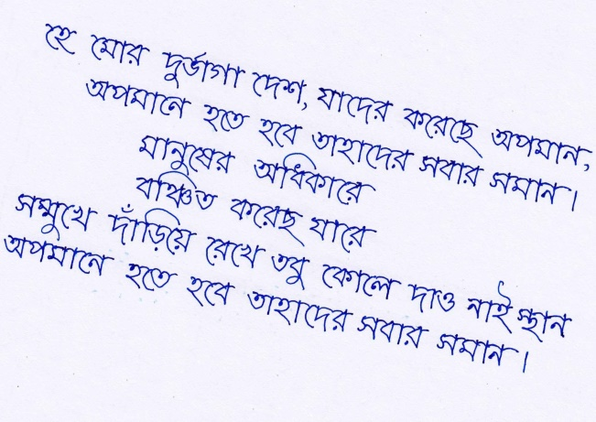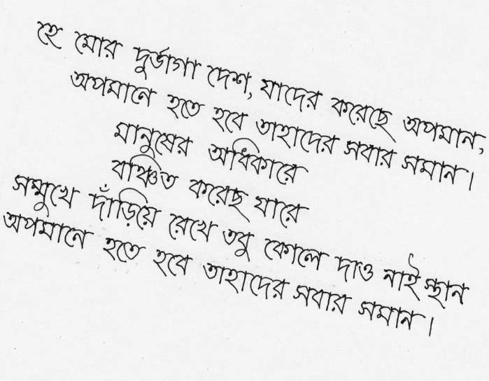
(a) (b)
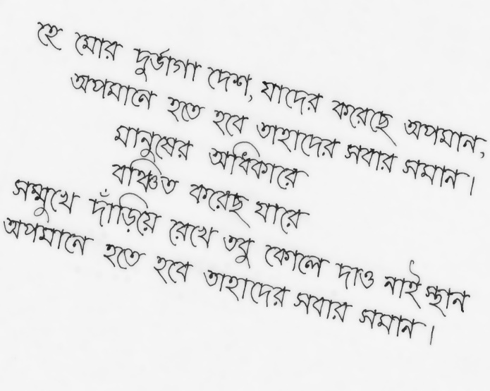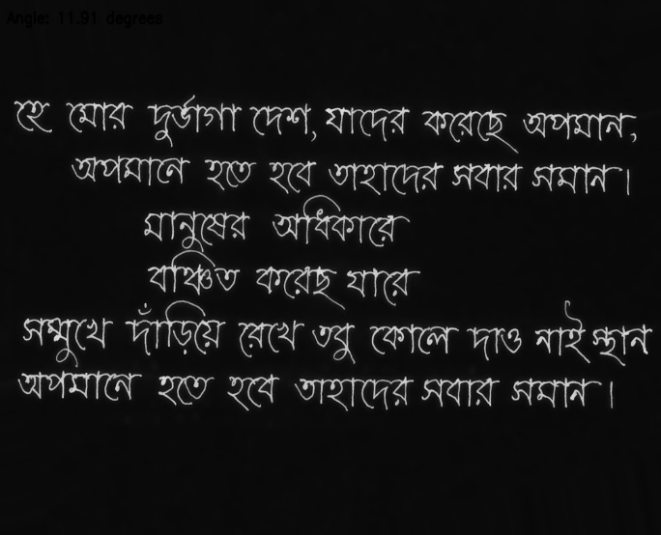
(c) (d)

Figure 2: Preprocessing for Bengali handwritten script
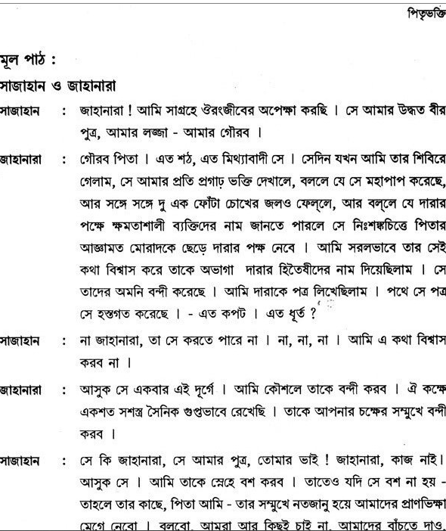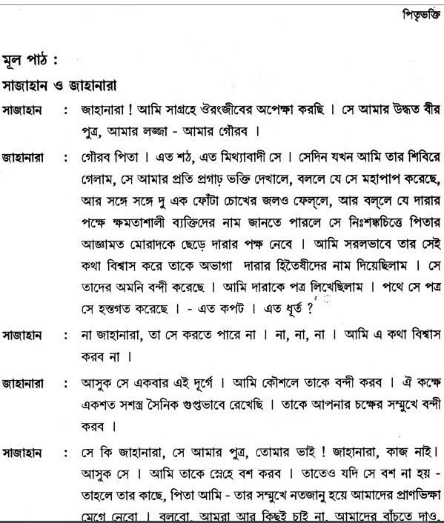
- (b)
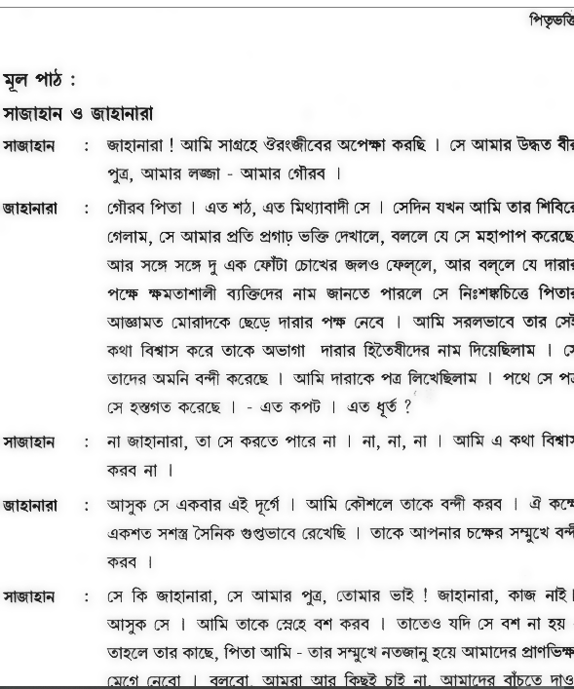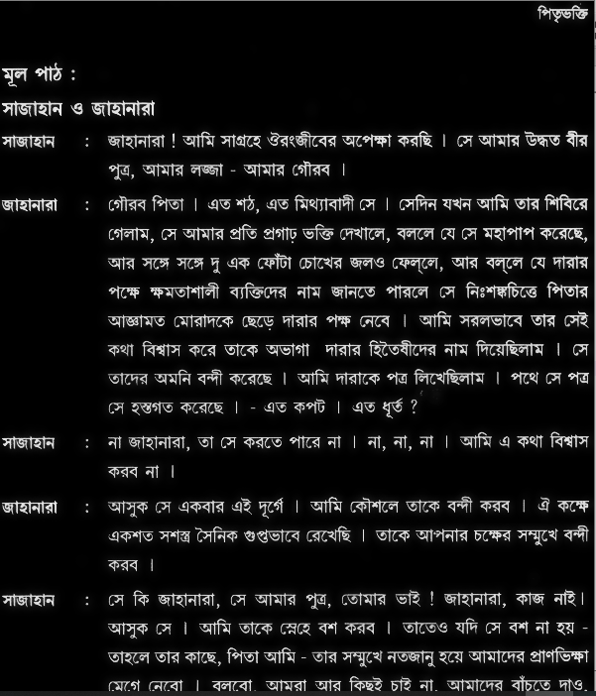
- (d)

Figure 3: Preprocessing for printed Bengali script
In Figure 2 and Figure 3, the preprocessing of the handwritten script and the printed script is shown. Here (a) indicates an RGB image or general image of the Bengali script as input. (b) is the result of applying the grayscale filter which turns the RGB input image into a grayscale image. Then (c) indicates the result of applying the bilateral filter which removes the noise of the image and smoothes it. The final stage of preprocessing is shown in (d), where the skew angle of the image is corrected and finally we get the binary image after image binarization and thus the image is ready for the segmentation stage.

Then the term is line segmentation. For line segmentation, we used Horizontal Projection Profile (HPP). The output of applying HPP on the printed script is displayed in Figure 4.

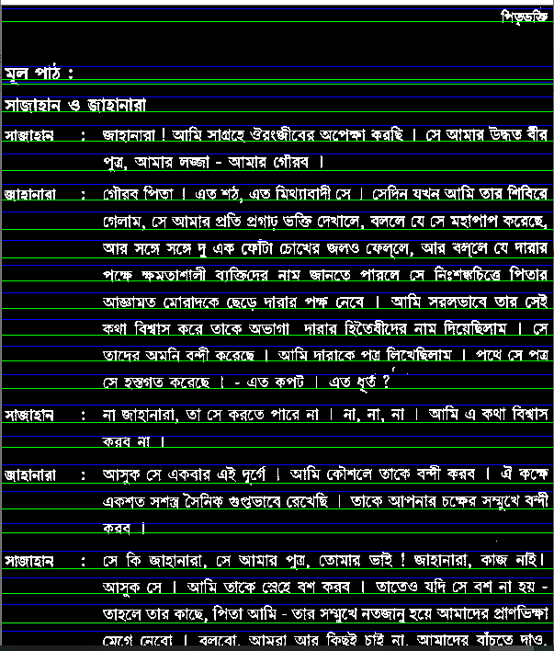

Figure 4: Line segmentation of printed Bengali script using HPP
Finally, for word segmentation, Vertical Projection Profile (VPP) is used. Figure 5 and Figure 6 depicts the result of applying VPP for both handwritten and printed Bengali script.
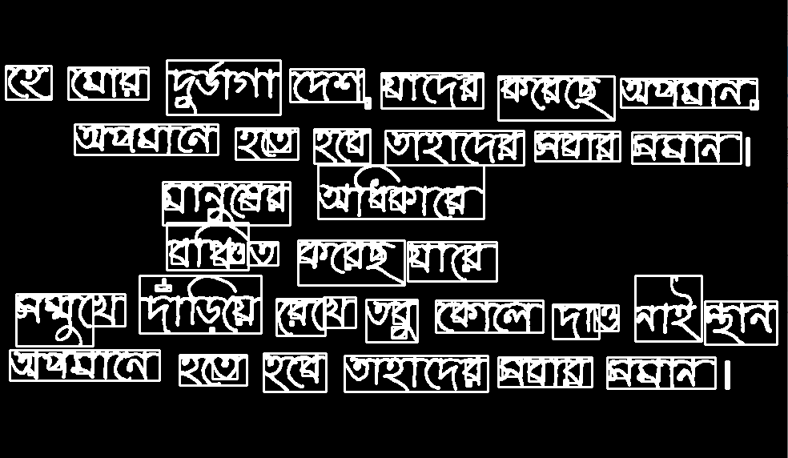
Figure 5: Word segmentation of handwritten Bengali script using VPP
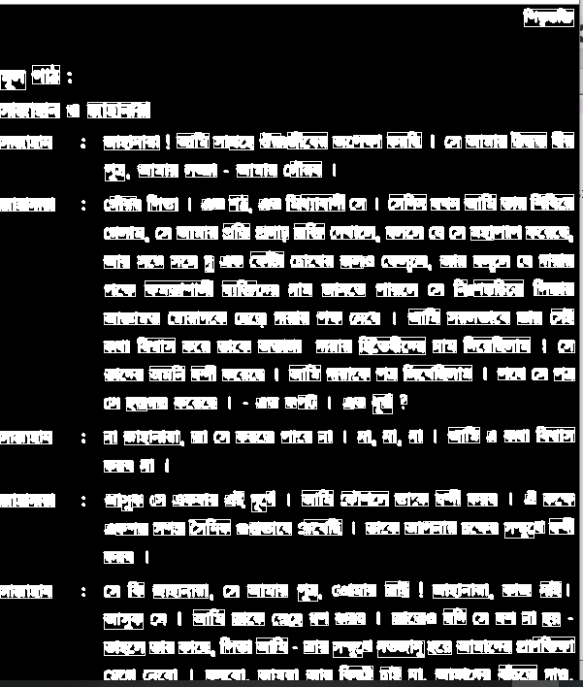
Figure 6: Word segmentation of printed Bengali script using VPP
- Conclusion:
In this paper, we have mainly focused on the segmentation procedure. For this segmentation, we use two types of Bengali script like the handwritten script and printed script as input. Then firstly the input image is preprocessed by four steps like grayscale filter, bilateral filter for smoothing the image, then we go for skew angle correction and finally by binarization we get the expected binary image. Then that binary image is used for the segmentation process where the lines and then words of the image are segmented one after another. Here lines are segmented by following horizontal projection profile and for word segmentation, vertical projection profile is used. Thus we able to segment the lines and words of input images.
In the future, we will try for character segmentation. As Bengali characters are connected through the matra line and the overall accuracy of the segmentation process is mostly depend on the proper detection of the matra line, so our future plan is to detect the matra line accurately.
References
- https://en.wikipedia.org/wiki/Bengali_alphabet
- T. Zahan, M.R. Selim, M.S. Rahman, M.Z. Iqbal, (2018). “Connected Component Analysis Based Two Zone Approach for Bangla Character Segmentation.” 1-4. 10.1109/ICBSLP.2018.8554684.
- M. A. Obaida, T. K. Roy, M. A. Horaira and M. J. Hossain, “Skew Correction Function of OCR: Stroke-Whitespace based Algorithmic Approach,” International Journal of Computer Applications 28(8):7-12, August 2011.
- S. S. Goswami, “Identification of Matra Region and Overlapping Characters for OCR of Printed Bengali Scripts,” Intelligent Computing and Information Science, Volume 135 of the series Communications in Computer and Information Science, pp. 606-612, 2011
- https://homepages.inf.ed.ac.uk/rbf/HIPR2/close.html
- https://docs.opencv.org/2.4/doc/tutorials/imgproc/erosion_dilatation/erosion_dilatation.html
- B. B. Chaudhuri and U. Pal, “A Complete Printed Bangla OCR System,” Pattern Recognition, Vol. 31, No. 5, pp. 531—549, 1998.
- U. Pal and S. Datta, “Segmentation of Bangla Unconstrained Handwritten Text”, Proc. 7th ICDAR, 2003.
- J. U. Mahmud, M. F. Raihan and C. M. Rahman, “A complete OCR system for continuous Bengali characters,” In Proceedings of the TENCON, 1372–1376, 2003.
- S. M. M. Mahmud, N. Shahriar, A.S.M D. Hossain, M. T. M. Chowdhury, and M.A. Sattar, “An Efficient Segmentation Scheme for the Recognition of Printed Bangla characters,” Proceedings of ICCIT, pp 283-286, 2003.
- M. A. M. Hasan, M. A. Alim, and M. W. Islam “A New Approach to Bangla Text Extraction and Recognition from Textual Image”, Proceedings of ICCIT, 2005.

